MTU Settings in SONiC
Introduction 2
Overview 2
Requirements 2
Assumptions 2
Port MTU 3
Host Interface MTU 3
APP DB Schema 3
SAI Attribute 5
SAI API 5
IP MTU 6
APP DB Schema 6
SAI Attribute 6
SAI API 7
Limitations 7
MTU Settings Design 7
References 8

Introduction

Overview

This document describes maximum transmission unit (MTU) configurations and behaviors in SONiC. In computer networking, the MTU of a communication protocol of a layer defines the size, in bytes, of the largest protocol data unit that the layer is allowed to transmit over one interface. One MTU is associated with each interface, layer and protocol.

In SONiC, there are two type of MTU for an interface based on layers.
- Port MTU (Layer 2): the largest number of bytes that can be carried by an Ethernet frame.
- IP MTU (Layer 3): the maximum size of an IP payload allowed to be transmitted over an L3 interface, excluding the L2 header and trailer.

Requirements
- The defaulted MTU is 1500, with a configurable range from 68 bytes to 9216 bytes. The minimum Ethernet Frame is 64 bytes, but our linux host can only take 68 bytes as minimum MTU. So we choose 68 bytes as the lower bound.
- The MTU configured on ASIC is 22 Bytes more than the MTU configured on corresponding host interface, which includes the overhead of L2 header (14 Bytes), FCS header (4 Bytes) and Vlan tag (4 Bytes).
- Port MTU and IP MTU can be configured with different values on the same interface. However, IP MTU should be capped by the Port MTU. Otherwise the IP packet larger the port MTU may still go out of the host interface, but get dropped by the ASIC.

Assumptions
- The Port MTU and IP MTU settings are configured through the new Config DB model.

Port MTU
Port MTU is configured by either CLI or Restful API talking to CFG manager, who updates the corresponding port objects inside CFG DB. Then portsyncd will set the MTU of the host interface via ip link set/ifconfig command under Linux environment. Upon success, portsyncd will push the config into PORT_TABLE inside APP DB. If there is any change with PORT_TABLE, its subscriber, PortsOrch, will add an extra 22 Bytes to the corresponding MTU, write into SAI DB and program the ASIC.
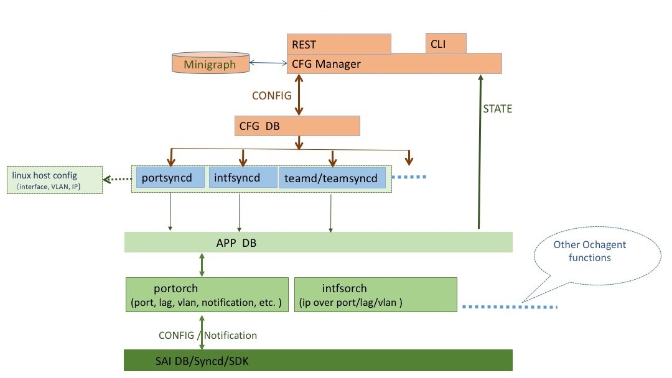

Host Interface MTU
admin@sonic:~$ sudo ifconfig Ethernet0
Ethernet0 Link encap:Ethernet HWaddr 00:05:64:30:17:ec
inet addr:10.1.0.1 Bcast:10.1.0.255 Mask:255.255.255.0
UP BROADCAST MULTICAST MTU:1500 Metric:1
RX packets:0 errors:0 dropped:0 overruns:0 frame:0
TX packets:0 errors:0 dropped:0 overruns:0 carrier:0
collisions:0 txqueuelen:1000
RX bytes:0 (0.0 B) TX bytes:0 (0.0 B)

APP DB Schema
### PORT_TABLE
Stores information for physical switch ports managed by the switch chip.

;Defines layer 2 ports
;In SONiC, Data is loaded from configuration file by portsyncd
;Status: Mandatory
port_table_key = PORT_TABLE:ifname ; ifname must be unique across PORT,INTF,VLAN,LAG TABLES
device_name = 1*64VCHAR ; must be unique across PORT,INTF,VLAN,LAG TABLES and must map to PORT_TABLE.name
admin_status = BIT ; is the port enabled (1) or disabled (0)
oper_status = BIT ; physical status up (1) or down (0) of the link attached to this port
lanes = list of lanes ; (need format spec???)
ifname = 1*64VCHAR ; name of the port, must be unique
mtu = 1*4DIGIT ; MTU for the interface
mac = 12HEXDIG ;

example:
127.0.0.1:6379> hgetall PORT_TABLE:Ethernet0
1) "lanes"
2) "1"
3) "alias"
4) "Ethernet0"
5) "oper_status"
6) "down"
7) "admin_status"
8) "down"
9) "mtu"
10) "1500"

Please note, the same schema is applicable for LAG. So the Port MTU can also be configured on LAG, and each LAG member ports will inherit the port MTU from LAG.

For example, we configured a LAG team0 with 3 member ports Etherent10, Ethernet11 and Ethernet12 with default MTU 1500. After changing the MTU of team0, the member port MTU will also get updated correspondingly.
admin@sonic:~$ sudo ifconfig team0 mtu 1600
admin@sonic:~$ redis-cli -n 0 keys *LAG*
1) "LAG_MEMBER_TABLE:team0:Ethernet10"
2) "LAG_MEMBER_TABLE:team0:Ethernet12"
3) "LAG_MEMBER_TABLE:team0:Ethernet11"
4) "LAG_TABLE:team0"
admin@sonic:~$ redis-cli -n 0 hgetall LAG_TABLE:team0
1) "admin_status"
2) "down"
3) "oper_status"
4) "down"
5) "mtu"
6) "1600"
admin@sonic:~$ redis-cli -n 0 hgetall "PORT_TABLE:Ethernet10"
1) "lanes"
2) "11"
3) "alias"
4) "Ethernet10"
5) "oper_status"
6) "up"
7) "admin_status"
8) "up"
9) "mtu"
10) "1600"
admin@sonic:~$ redis-cli -n 0 hgetall "PORT_TABLE:Ethernet11"
1) "lanes"
2) "12"
3) "alias"
4) "Ethernet11"
5) "oper_status"
6) "up"
7) "admin_status"
8) "up"
9) "mtu"
10) "1600"
admin@sonic:~$ redis-cli -n 0 hgetall "PORT_TABLE:Ethernet12"
1) "lanes"
2) "21"
3) "alias"
4) "Ethernet12"
5) "oper_status"
6) "up"
7) "admin_status"
8) "up"
9) "mtu"
10) "1600"

SAI Attribute
sai_attribute_t attr;
attr.id = SAI_PORT_ATTR_MTU;
attr.value.u32 = mtu;

SAI API
sai_status_t status = sai_port_api->set_port_attribute(id, &attr);

IP MTU
Similarly, the IP MTU is also configured through CLI/Restful API which sets if_mtu value of the router interface objects inside CFG DB. Then Intfsyncd copies the corresponding change into APP DB. Upon receiving update notification from APP DB, IntfsOrch pushes the if_mtu value into SAI DB, and adds the MTU attribute to the attribute list during the sai router interface creation.

APP DB Schema
### INTF_TABLE
intfsyncd manages this table. In SONiC, CPU (management) and logical ports (vlan, loopback, LAG) are declared in /etc/network/interface and loaded into the INTF_TABLE.

IP prefixes are formatted according to [RFC5954](https://tools.ietf.org/html/rfc5954) with a prefix length appended to the end

;defines logical network interfaces, an attachment to a PORT and list of 0 or more
;ip prefixes
;
;Status: stable
key = INTF_TABLE:ifname:IPprefix ; an instance of this key will be repeated for each prefix
IPprefix = IPv4prefix / IPv6prefix ; an instance of this key/value pair will be repeated for each prefix
scope = "global" / "local" ; local is an interface visible on this localhost only
if_mtu = 1*4DIGIT ; MTU for the interface
family = "IPv4" / "IPv6" ; address family

example:
127.0.0.1:6379> hgetall INTF_TABLE:Ethernet0:10.1.0.1/24
1) "scope"
2) "global"
3) "family"
4) "IPv4"
5) "if_mtu"
6) "1500"

SAI Attribute
if_attr.id = SAI_ROUTER_INTERFACE_ATTR_MTU;
rif_attr.value.u32 = mtu;
rif_attrs.push_back(rif_attr);

SAI API
sai_status_t status = sai_rif_api->create_router_interface(&rif_id, rif_attrs.size(), rif_attrs.data());

Limitations
- SAI_ROUTER_INTERFACE_ATTR_MTU is not handled in current brcm_sai. So the asic is not programmed correctly with the ip mtu. Have provided the fix to Broadcom.
- There is no attribute update path for router interface in current SONiC. So the ip mtu can only being set during the router interface creation. Needs to implement set_router_interface_attribute and get_router_interface_attribute after config DB and interface schema are in place.

MTU Settings Design

If the Kernel MTU is configured on the linux host interface, the corresponding port will use the Kernel MTU with an additional 22 Bytes as SAI_PORT_ATTR_MTU. Any router interface created on the port, will use Kernel MTU as SAI_ROUTER_INTERFACE_ATTR_MTU.

Summary:

Kernel MTU = IP MTU = Port MTU – 22 Bytes

Config DB Schema

"PORT": {
"Ethernet8": {
"alias": "Ethernet9",
"mtu": "1500"
},
…
},

"PORTCHANNEL": {
"PortChannel10": {
"fallback": "true",
"members": [
"Ethernet10"
],
"mtu": "1500"
},
…
},

References
- SONiC Configuration Management
- https://github.com/Azure/SONiC/wiki/Architecture

- Add config check in config manager to reject invalid config
- Apply ip mtu on both linux host interface and SAI_ROUTER_INTERFACE
- Trap frames exceeding MTU to CPU?

